

Python Practical’s

# TASK 3

Smit Joshi | 06-08-2023

# Practical 1

Write a program to find whether the given number from user is Positive,

Negative or Zero.

number=int(input("Enter Number "))

if number>0:

    print(f"Number is Positive")

elif number<0:

    print(f"Number is Negative")

else:

    print("Number is Zero")

### Output:

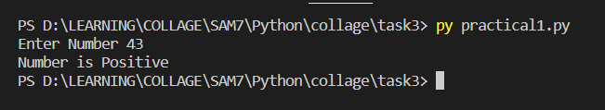

# Practical 2

Write a program to split the input data into rupees and paisa (For eg. INPUT

59.47 as Rs 59 and 47 paisa ).

number=input("Enter Money: ")

money=number.split('.')

print(f"rupees: {money[0]} and paisa: {money[1]}")

### Output:

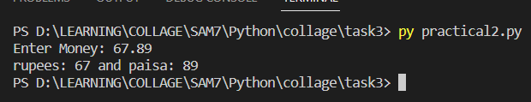

# Practical 3

Write a python program to display the following pattern

*

* *

* * *

* * * *

* * * * *

n=int(input("Enter Number: "))

for i in range(1,n+1):

    for j in range(i):

        print("*",end="")

    print()

### Output:

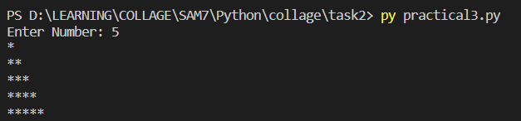

# Practical 4

Write a python program to take two numbers from user and apply inbuilt function to find absolute of no, ceil of NUMBER, floor, max, min, power, sqrt, round off the two numbers.

import math

num1=int(input("Enter Number 1 "))

num2=int(input("Enter Number 2 "))

# Applying functions

print(f"Absolute of {num1}/{num2}:",abs(num1/num2))

print(f"Ceil of : {num1}/{num2}:",math.ceil(num1/num2))

print(f"floor of : {num1}/{num2}:",math.floor(num1/num2))

print(f"Max between : {num1} and {num2}:",max(num1,num2))

print(f"Min between : {num1} and {num2}:",min(num1,num2))

print(f"power of : {num1} is {pow(num1,2)} and {num2} is {pow(num2,2)}")

print(f"sqrt of: {num1} is {math.sqrt(num1)} and {num2} is {math.sqrt(num2)}")

print(f"Round off Of {num1}/{num2} is {round(num1/num2,2)}")

### Output:

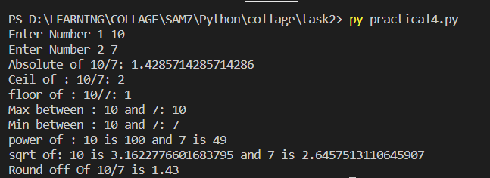

# Practical 5

## Write a python program to generate 20 numbers randomly in between 41 to 75.

import random

for i in range(41,76):

    print(random.randrange(41,76),end=" ")

### Output:



# Practical 6

Write a python program to find input string is ALPHABET, NUMERIC and

alphanumeric or is space.

testString=input("Enter Something... ")

print(f"{testString} is Alphabet: {testString.isalpha()}")

print(f"{testString} is Numeric: {testString.isnumeric()}")

print(f"{testString} is Alpha Numeric: {testString.isalnum()}")

print(f"{testString} is Space: {testString.isspace()}")

### Output:

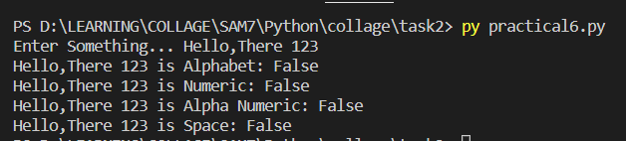

# Practical 7

Write a python program to implements function on the string

- capitalize - center - count - find - lower

- upper - replace - split - swap-case

testString=input("Enter String: ")

print(f"Capitalize: {testString.capitalize()}")

print(f"Center: {testString.center(50)}")

print(f"count: {testString.count('s')}")

print(f"find: {testString.find('s')}")

print(f"lower: {testString.lower()}")

print(f"upper: {testString.upper()}")

print(f"replace: {testString.replace('M','S')}")

print(f"split: {testString.split(' ')}")

print(f"swap-case: {testString.swapcase()}")

### Output:

